STARTING UP

1 Open your Oracle and access your account.

2 Did you load the script that populates the database?

3 Open Blackboard to quiz 1, found under course documents.

Les01 -- SELECT – review but using Oracle

These are the commands used on the course

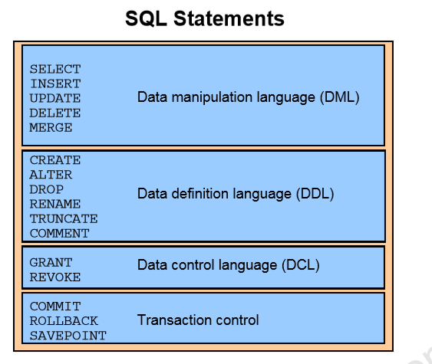

NOT MANY …..

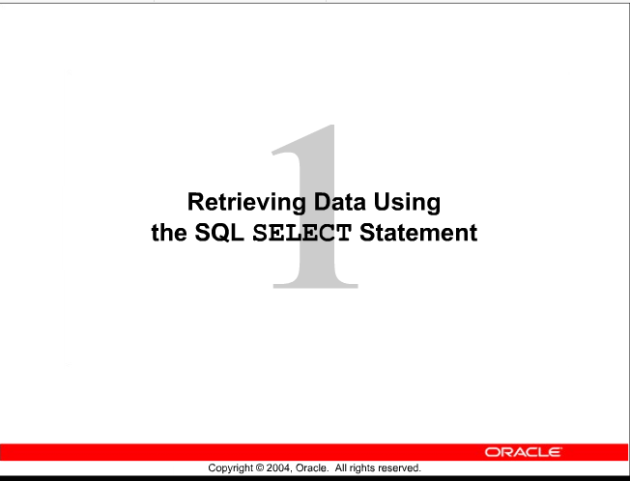

Much of this will be a quick review at this time

2

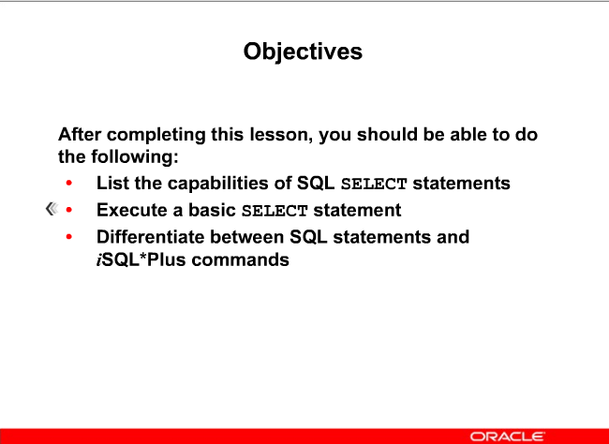

SCHEMA – working with this semester

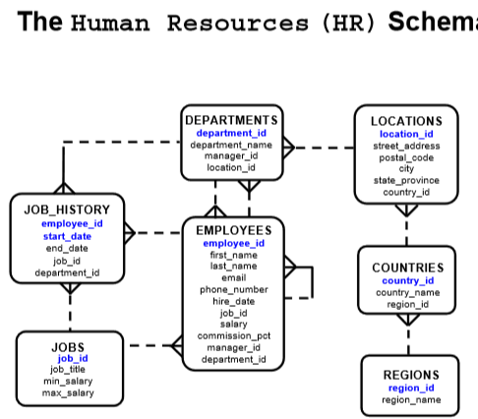

REWRITE this in a better layout for readability

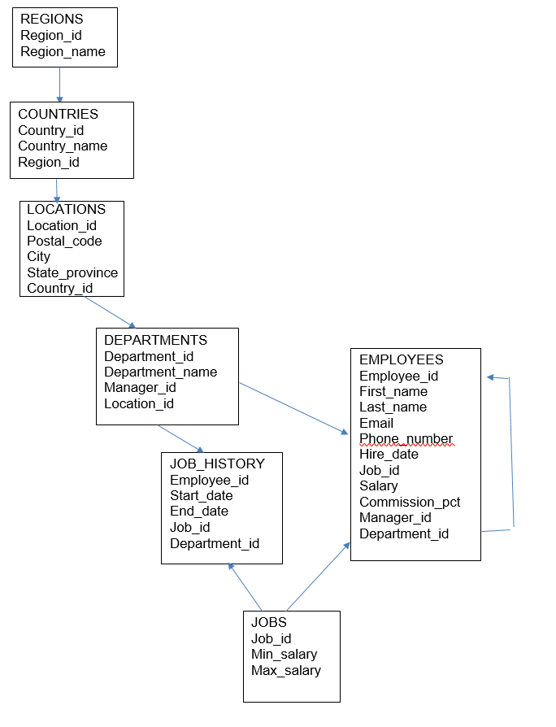

3 (1-4) _ repeats DBS201 – and why?

# 3 ACTIONS ON TABLES

* + **1 PROJECTION**
  + **2 SELECTION**
  + **3 JOINS**
  + **Done through SELECT statement**

SELECT – Retrieving data from a table

**1 PROJECTION** -- Retrieving **specific columns** of data such as ALL student names and phone numbers



**2 SELECTION** – Returns **only rows** that meet the specific restriction such as all male students from a table of students

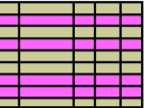

**3 JOIN** – Returning **data from 2 different** tables such as course name and the student name

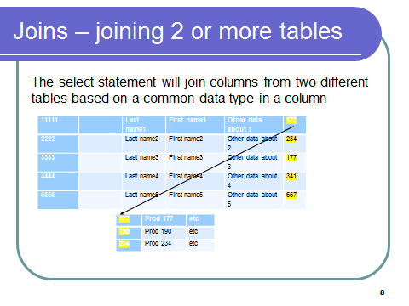

More on this in a later week’s lesson

FORMAT of the SELECT statement

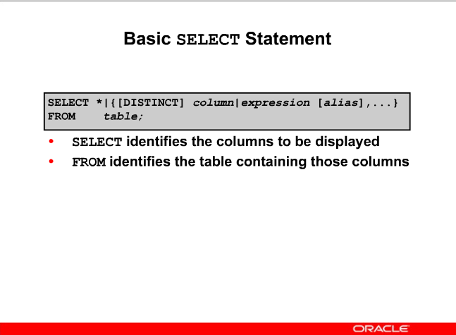

**SQL STYLE**

**It is important NOT to use run on sentences**

This and similar styles will not be marked and so will get zero

SELECT LAST_NAME, FIRST_NAME, ADDRESS1, ADDRESS2, CITY, PROV, PCODE FROM EMPLOYEES WHERE UPPER(CITY) = UPPER (‘TORONTO’);

Vs

SELECT LAST_NAME, FIRST_NAME, ADDRESS1, ADDRESS2, CITY, PROV, PCODE

FROM EMPLOYEES

WHERE UPPER(CITY) = UPPER (‘TORONTO’);

OR

SELECT LAST_NAME, FIRST_NAME, ADDRESS1, ADDRESS2,

CITY, PROV, PCODE

FROM EMPLOYEES

WHERE UPPER(CITY) = UPPER (‘TORONTO’);

More data later about style

PROJECTION –

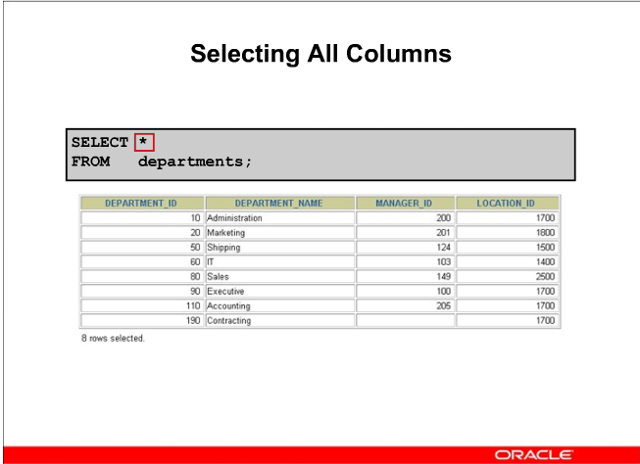

DEMO

Use the DESCRIBE command to see the structure of a specific table.

OR

SELECT * FROM TABS: 🡸 to see all the tables -- hard to read

OR

Left panel and click on table 🡸 demo this

SELECTION --

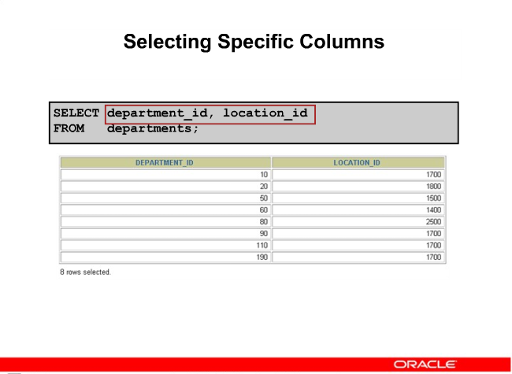

Can also do UPPER and LOWER case like this

SELECT department_id, location_id

FROM departments;

Demo cut and paste for labs

Also fixed font -- courier new

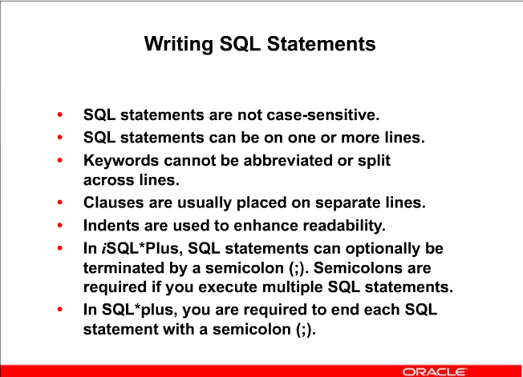

MAIN POINT is readability

LAYOUT is important. Bad layout will have marks deducted.

9

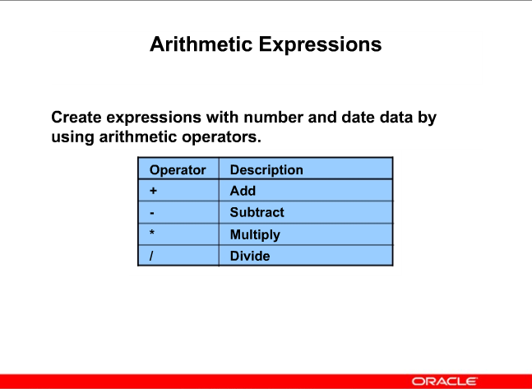

Same as any programming language

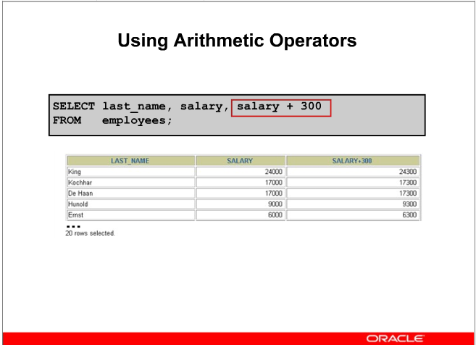

Note how it adds to the salary an additional 300

As in ALL languages it is important to know the order of operation when there are multiple operators

SELECT last_name, salary, salary + 300

FROM employees;

**PROBLEM to each try:**

**Load the answer in Quiz 1 question 1**

**Look at the EMPLOYEES table**

**We will assume the salary value for now is monthly**

**Show**

1. **yearly salary.**
2. **Raise everyone’s salary by 100 dollars per month, then multiply it out by 12 to see yearly salary**

Try it now, put the SQL and the answer into Quiz1 on Blackboard

11

Raise everyone’s salary (which we will assume is monthly) by 100 dollars then multiply it out by 12 to see yearly salary

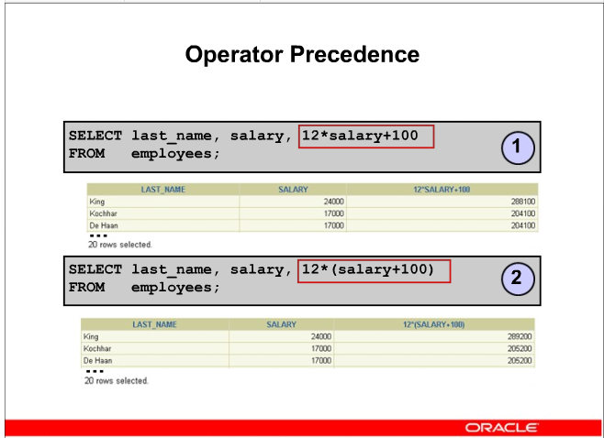

289,200

288,100 is the result

Not a large difference for EACH employee.

For the company with 20 employees that is 24,000

Now if you have 1000 employees, that raise is 24 million.

Would be nice if we could total the salaries to see the results.

12

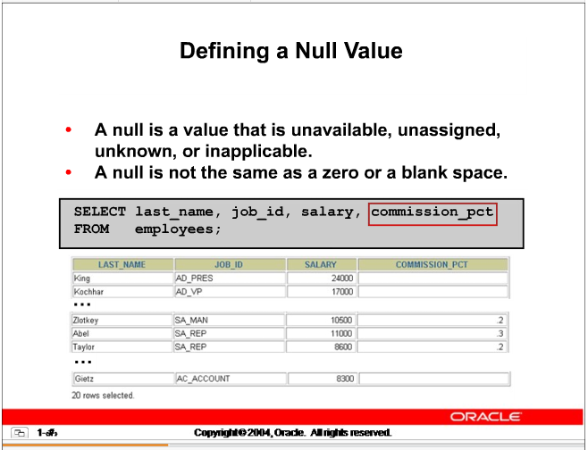

**PROBLEM for you to solve**

Show

1. Last Name
2. Multiply the monthly salary by 12 to get yearly salary.
3. Then multiply it by the percent to get the commission earned

13

**PROBLEM**

Multiply the monthly salary by 12 to get yearly salary.

Then multiply it by the percent to get the commission earned

SELECT last_name, salary, salary * 12 * commission_pct

FROM employees;

THIS PROBLEM WILL HAPPEN TO YOU MANY TIMES

What Happens ….

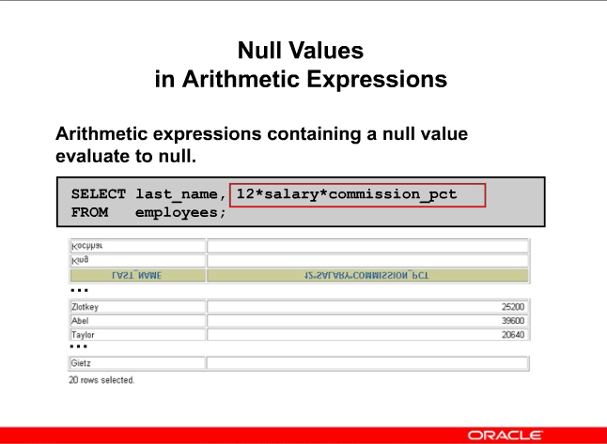

SELECT last_name, salary * 12 * commission_pct

FROM employees

# NOTE: Column Names are not nice – need to fix it with an alias

LAST_NAME SALARY*12*COMMISSION_PCT

------------------------- ------------------------

King

Kochhar

De Haan

Hunold

Ernst

Lorentz

Mourgos

Rajs

Davies

Matos

Vargas

Zlotkey 25200

Abel 39600

Taylor 20640

Grant 12600

Whalen

Hartstein

Fay

Higgins

Gietz

20 rows selected

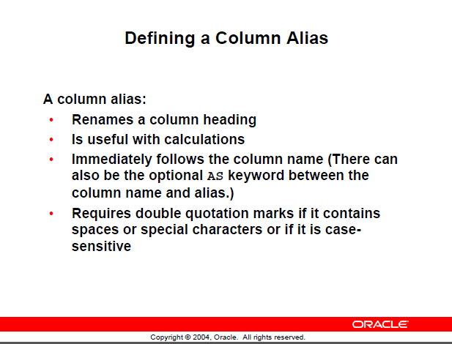

**NOTE: Alias names maximum length of 30**

Try these.

SELECT last_name AS name, commission_pct as comm

FROM employees;

SELECT last_name AS Last Name, commission_pct as comm

FROM employees;

-- This last one will not work as there is a space in the alias name

**PROBLEM:**

Display last name and job id from the employees table and look at the result

SELECT last_name, job_id AS "Employees"

FROM employees;

CUT and PASTE to word or blackboard

Results are spread out and title Employees ---- in wrong location ……

LAST_NAME Employees

------------------------- ----------

Abel SA_REP

Davies ST_CLERK

De Haan AD_VP

Ernst IT_PROG

Fay MK_REP

Gietz AC_ACCOUNT

Wanted

LAST_NAME Employees

------------------------- ----------

Abel SA_REP

Davies ST_CLERK

De Haan AD_VP

Change the look with a **CONCATENATE OPERATOR**

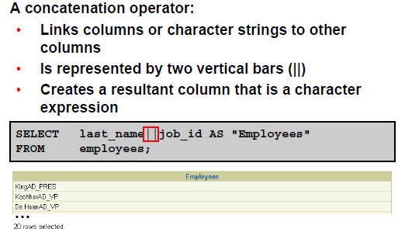

Notice this works whereas on the iSeries it "appeared" to not work.

select last_name || job_id as "Employees"

from employees;

STILL NOT NICE LOOKING ………. Need to improve it.

**How ????? do it in question 3**

ASIDE: There is a concatenate function available later

ANSWER:

select last_name || ' ' || job_id as "Employees"

from employees;

Employees

------------------------------------

Abel SA_REP

Armarillo SA_REP

Bergsteige SA_REP

Brigade SA_REP

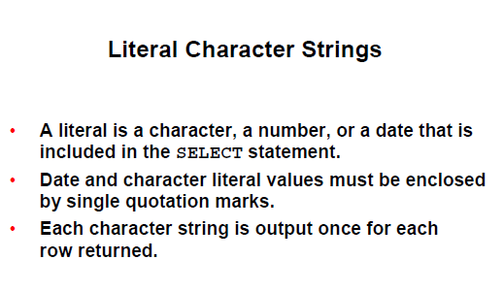

**NOTE:**

**Single quotes for literals**

**Double quotes for alias names**

**PROBLEM Question 4:**

**Revise previous SQL 🡪 require Last name and job id with the ‘is a’ between it but nicely displayed**

**Give it a good title**

Example:

Ron is a Dean

(answer on next page)

**ANSWER Question 4:**

**Revise previous SQL 🡪 require Last name and job id with the ‘is a’ between it but nicely displayed**

**Give it a good title**

select last_name || ' is a ' || job_id as "Employees"

from employees;

🡸 note the spacing in the quotes

Always look at your output carefully

**ALTERNATE – do not recall ever seeing it used … but**

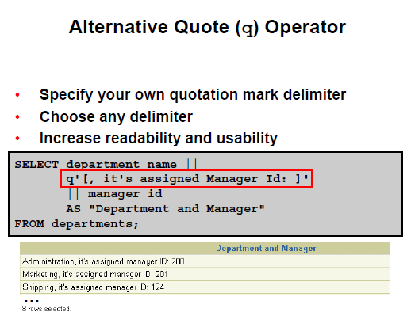

SELECT last_name|| q'[ has the job: ]' || job_id

FROM employees;

**PROBLEM Question 5:**

**A question from the consultant hired to get more sales.**

**How many departments does the company have?**

**Using the employees table, display all the departments**

**ANSWER Question 5**

**SELECT department_id 🡨 could use department names but then need a join**

**FROM employees;**

**Did you do this.**

**Look carefully at the results, is that what the consultant really wanted?**

-- 54 rows

See the duplicates as there are 20 rows displayed

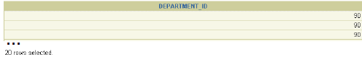

**SELECT DISTINCT department_id**

**FROM employees;**

DEPARTMENT_ID

-------------

10

20

50

60

80

90

110

8 rows selected.

PROBLEM:

Show the distinct salary and job id within department. Meaning if two people in department 20 have the same salary and job_id only show one of them.

SELECT DISTINCT (salary, job_id), department_id

FROM employees

ERROR 🡺 see message … does not look like the error is correct

Error starting at line : 1 in command -

SELECT DISTINCT (salary, job_id), department_id

FROM employees

**Error at Command Line : 1 Column : 24 🡸 this usually will help you**

Error report -

SQL Error: ORA-00907: missing right parenthesis

00907. 00000 - "missing right parenthesis"

WHY?

Correction will generate 37 rows

If you use DISTINCT, it must be for ALL selected columns

SQLPLUS command and NOT SQL

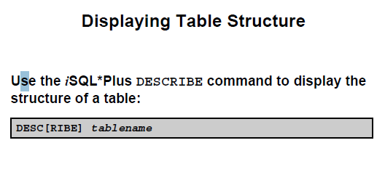

This is not SQL it is a SQL*Plus command and does not need a semicolon

